Live Test

Q1. Which method is used to rename columns in a pandas DataFrame df?

1. df.rename(columns={})
2. df.columns.rename()
3. df.relabel(columns=[])
4. df.columns()

Ans:A

Q2. Which method is used to read CSV file?

1. pd.read()
2. pd.read_csv()
3. pd.csv()
4. pd.get_csv()

Answer: B

Q3. How do you set a specific column as the index of a DataFrame df?

1. df.set_index('column_name')
2. df.setindex('column_name')
3. df.index('column_name')
4. df.set_index(column_name)

Answer: A

Q4. What will be the result of df.isna().sum() on a DataFrame df?

1. Sum of all values in the DataFrame.
2. Sum of all NaN values in the DataFrame.
3. Count of NaN values in each column.
4. Count of NaN values in each row.

Answer C

Q5. What is the difference between .loc and .iloc for accessing data in a DataFrame?

1. .loc uses labels, .iloc uses index positions
2. .loc creates a copy, .iloc modifies the original
3. .loc is for numeric indexing, .iloc is for string indexing
4. There's no significant difference

Answer: A

Q6. What is the .apply() method used for in a DataFrame?

1. Renames columns
2. Aggregates data using a function
3. Selects specific rows
4. Applies a function element-wise to each column

Answer: D

Q7. Which of the following is not true about dataframe?

1. A dataframe object can be created by passing dictionaries.
2. A dataframe is size immutable.
3. A dataframe index can be string.
4. A column of dataframe can have data of different types.

Answer B

Q8. Which of the following statement for creating dataframe is valid?

1. df = pd.dataframe(dict1)
2. df = pd.Dataframe(dict1)
3. df = pd.dataFrame(dict1)
4. df = pd.DataFrame(dict1)

Answer D

Q9. To count total no of elements in a dataframe we use ____?

1. size
2. len
3. count
4. values

Answer:A

Q10. To extract the first three rows and three columns of a dataframe ‘exp’ which of the following is True ?

1. exp.iloc[0:2,0:2]
2. exp.iloc[0:3,0:3]
3. exp.iloc[1:3,1:3]
4. exp.iloc[1:4,1:4]

Answer:B

Q11. Considering following dataframe 'class'.

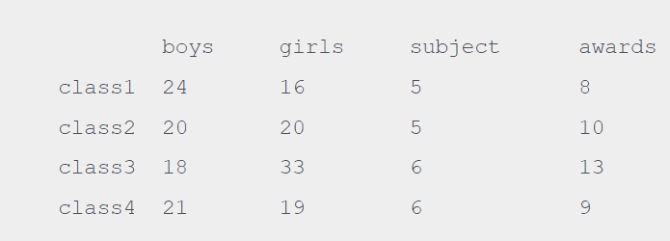

Which of the following is not correct?

1. print(class.loc[:,'girls':'subject'])
2. print(class.loc['class1':'class2','girls':'subject']
3. Print(class.loc[['class1','class2'],['girls','subject']]
4. Print(class.loc['class','girls']

Answer: D

Q12. A dataframe object can be created using:

1. Python Dictionary
2. Python List
3. Panda Series
4. All of the above

Answer D

Q13. Astha has given following command to delete a column ‘pub’ from ‘book’ dataframe.

book.drop(‘pub’)

But she is not getting desired output, help her to select correct statement.

1. book.drop([‘pub’])
2. book.drop([‘pub’], axis = 0)
3. book.drop([‘pub’], axis = 1)
4. none

Answer: C

Q14. (i) a dataframe is size mutable and value mutable

(ii)the axis = 1 identifies the column index of dataframe

1. both are false
2. both are true
3. (i) true (ii) false
4. (i) false (ii) true

Answer: B

Q15. For the below given dataframe --

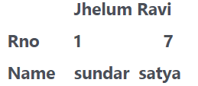

Python will store data for ‘jhelum’ column as

1. float
2. int
3. string
4. object

Answer: D